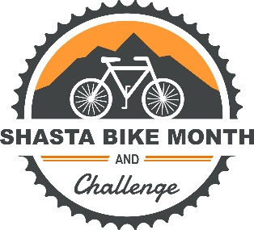

PRESS RELEASE

Contact: Sara Sundquist, Healthy Shasta, 530-945-8598
Angie James, Chain Gang Bike Shop, 530-524-1917

Date: March 22, 2021

The Great Bike Giveaway to Award an E-bike to Celebrate
Bike Month

SHASTA COUNTY – The Shasta Bike Month Workgroup, along with Pedego Redding, is giving away an e-bike to a Shasta County resident in need of transportation. The Great Bike Giveaway is accepting applications from March 22 to April 19. Applications are available at www.shastabikechallenge.org.

The application is easy to complete and asks applicants to tell their stories of where they would go on an e-bike, such as school, work, and errands. The winner will be determined by the Shasta Bike Month Workgroup and announced at the end of April. The Great Bike Giveaway provides much needed transportation to an individual, highlights the utility of e-bikes, and promotes the journey (distance and destinations) of the e-bike awardee throughout May.

Starting in April, the annual Shasta Bike Challenge will be open for worksites, schools, social groups, and families to sign up for the Bike Challenge, which runs from May 1 - 31. Participants are entered into a free drawing for local prizes each day they ride a bike. Each bike trip also counts toward the National Bike Challenge with larger prizes on the national level. Workplaces and teams compete for prizes and recognition. To qualify for prizes in this free challenge, bicycling can be done for transportation or recreation on streets or trails. Participants can be experienced cyclists, or brand new to the sport!

Other great events taking place to encourage people to go for a spin include:
- The Ride of Silence organized by the Shasta Wheelmen.
- Ride with a Transportation Official to highlight local bike routes by Caltrans and the City of Redding.
- A scavenger hunt by bike – pedal to all the destinations in one ride or take several weekends to complete.
- And more!

For more details about these and more great bicycle activities, visit www.shastabikechallenge.org.

Shasta Bike Month & Challenge is supported by: Healthy Shasta, Redding Parks and Trails Foundation, Shasta Living Streets, Shasta Wheelmen, Shasta Regional Transportation Agency (SRTA), Caltrans District 2, Redding Area Bus Authority (RABA), Chain Gang Bike Shop, Cornerstone Community Bank, Enjoy Magazine, Sports LTD, The Bike Shop, Bikes Etc., Pedego Redding, Jefferson State Adventure Hub, Trails & Bikeways Council of Greater Redding, Shasta County Health and Human Service Agency - Public Health, Shasta Family YMCA, Churn Creek Meadow Organic Farm, Headwaters Adventure Company, Starbucks, and other organizations who support bicycling.

# # #

